
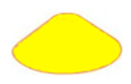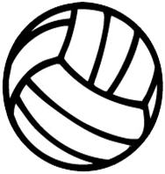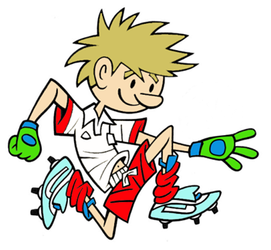

1 23
RULES - HOW TO PLAY

Roll ball from base to hit wall between domes, and catch rebound

If successful at base1 move back to base 2 and then 3

Give different scores for successful rolls from each different dome e.g. 1pt for blue, 2pts from green etc.

Players may play individually or in pairs especially if there is no wall

FOCUS
To challenge player’s rolling skills at a target
TARGET GAME: Game 1
GAME: Roller Ball
HARDER
- Move further back from target
- Make target narrower
- Roll while on the move
- Use hand/fist/foot/bat/hurl to aim ball through target

EASIER
- Move closer to target
- Make target bigger
- Sit/kneel to roll

COACHING POINTS
HEAD
- Sending - Look at target before throw
- Receiving - Watch ball all the way into hands
HANDS
- Sending: Bowling Roll - Keep throwing hand behind the ball with fingers pointed towards the ground
- Use other hand to support ball at front
- Receiving: Backs of hands on ground and scoop ball up into chest
FEET
- Start with feet shoulder width apart, more skilful children should stand one foot in front of other and use the more difficult Bowling Roll
EQUIPMENT

- Large Soft Balls

- Domes

- Bats/Hurls

Copyright Ulster Council GAA 2009

